***PROJECT REPORT***

***on***

***Payroll Management System***

*(Btech AI&DS III Semester Mini project)*

*2020-24*



***Submitted to: Submitted by****:*

*Department of computer Applications**Ayush Rawat(05)*

*University Roll Number: 2017639*

*Under the guidance of* ***Mr. Kireet Joshi***

*DEPARTMENT OF COMPUTER SCIENCE AND INFORMATION TECHNOLOGY*

***GRAPHIC ERA DEEMED TO BE UNIVERSITY, DEHRADUN***

***DECLARATION***

# I, **Ayush Rawat** student of **B-tech, Semester 3**, Department of Computer Science and Engineering, Graphic Era Deemed To Be University, Dehradun, declare that the technical project work entitled “Payroll Management System” has been carried out by me and submitted in partial fulfillment of the course requirements for the award of degree in B-tech of **Graphic Era Deemed To Be University** during the academic year **2021-22**. The matter embodied in this synopsis has not been submitted to any other university or institution for the award of any other degree or diploma.



***ACKNOWLEDGEMENT***

I would like to take this opportunity to express my gratitude to entire faculty at Department of Computer Science and Information Technology, Graphic Era Deemed To Be University, Dehradun who evaluated the project from time to time and gave me the valuable suggestions as to how to improve the project.

I am grateful to **Mr. Kireet Joshi**, Graphic Era Deemed To Be University, for his supervision, encouragement, inspiration, and guidance. Working under him is being an enriched experience. In all, I found congenial work environment in Graphic Era University, Dehradun and this project completion will mark a new beginning for me in the coming days.

I am highly indebted to Graphic Era University for providing me the required infrastructure and facilities to accomplish the given task.

Ayush Rawat

Btech AI&DS

2020-24

Graphic Era University

***PAYROLL MANAGEMENT SYSTEM***

* ***Problem Statement***:

To prepare project on Payroll Management System using C++ that deals with the financial components of an employee’s salary, allowances, deductions, gross pay, net pay, pay slip generation for a given time.

* ***Language Used***: C++.
* ***Introduction and Motivation***:

The “Payroll Management System” has been developed to override the problems prevailing in practicing manual system. It can assist the user to concentrate on the record keeping. Thus it will help organization in better utilization of resources. Payroll Management System can lead to error free, secure, reliable and fast management system.

The aim is to automate its existing manual system by the help of computerized equipments and software, fulfilling their requirements, so that their valuable data/information can be stored for longer period with easy accessing and manipulation of the same. Basically the project describes how to manage for good performance and better services for the clients.

* ***Development Environment & Tools Used:***

Hardware Configuration:

Processor : Intel corei5

Ram : 8GB

Software Configuration:

Operating system : WINDOWS 10

Programming language : C++

Features Used : files, class, function

For coding, Code blocks IDE is used.

* ***Header Files used:***
* **Iostream** : It stands for standard input-output stream. This header file contains definitions of objects like cin, cout, cerr, etc.
* **Stdio.h** : This header file contains definition of printf, scanf, all file handling functions, FILE pointer,etc.
* **Conio.h** : The conio stands for Console-Input-Output. The conio.h is a non standard header file used in c and c++. This file contains console input-output functions which are mostly used by MS-DOS compilers like clrscr(), getch(), textcolor() etc.
* **Windows.h** : This is a wndows-specific header file for c and c++ programming languages which contains declaration for all the functions in the windows API, all the common macros used by windows programmers.
* **Time.h** : This header file contains definitions of functions to get and manipulate date and time information.

#### **Features:**

* **Login Page**: The page where the admin users will log in their system credentials to access the system.
* **Home Page**: The page where the admin will be redirected by default after logging into the payroll management system.
* **Allowance List Page**: The page where the admin/staff will manage the list of allowances.
* **Deduction List Page**: **​​​​​​​**The page where the admin/staff will manage the list of deductions.
* **Employee List Page**: **​​​​​​​**The page where the admin will manage the list of the employees. This also the page where the admin will manage the employees’ allowances and deductions.
* **Employee Leave Page**: **​​​​​​​**The page where the admin will see and manage the employees’ leave records.
* **Employee’s Pay-slip Modal**: **​​​​​​​**The popup modal that displays the employee’s pay-slip.
* ***Use Case Diagram:***

A[use case diagram](https://www.google.com/url?sa=t&rct=j&q=&esrc=s&source=web&cd=&cad=rja&uact=8&ved=2ahUKEwiYy4finOnwAhUbPXAKHeqxDyAQFjACegQICxAD&url=https%3A%2F%2Fwww.smartdraw.com%2Fuse-case-diagram%2F&usg=AOvVaw1paPH3m325jLG07S4AOK-M) is a visual representation of how a user might interact with a program. A use case diagram depicts the system’s numerous use cases and different sorts of users. The circles or ellipses are used to depict the use cases.  
By creating the use case of the Payroll Management System, one must determine first the possible features to identify the flow of the system.

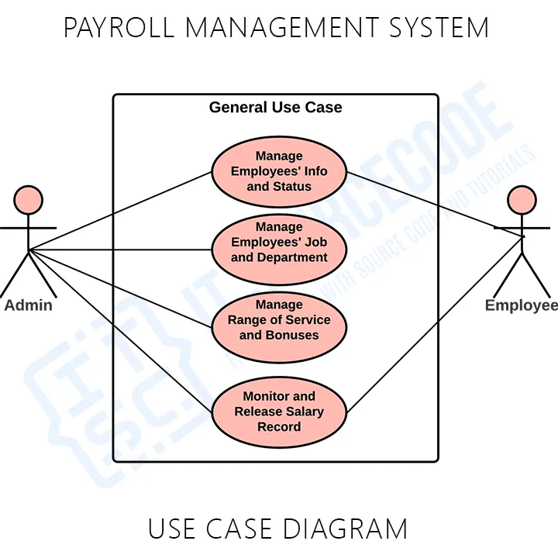

* ***Methodology Followed:***

## C++ has been used for the designing and implementation of this project. Project includes

object oriented and generic programming features like:

1. **Objects**: Object is basic unit of object oriented programming. Object are identified by its unique name. An object represents a particular instance of class and can hold its own relevant data.
2. **Classes**: Classes are the data types on which objects are created. Objects with similar properties and methods are grouped together to form a class.

Classes contain data members and member functions.

The variables which are declared in any class by using any fundamental data types(int, char, etc) or derived data types(class, structure, etc) are known as **Data Members** and the functions which are declared either in private or public section are known as **Member Functions.**

The project uses the concept of **File Handling** to store the details of employees’.

1. **File Handling:** File handling provides a mechanism to store the output of a program in a file and to perform various operations on it.

Some of the operations performed are:

1. Creation of new file: fopen (name of the file, attributes like “r”, “w”, “a”).

// “r”->opens file in read mode, “w”->opens file in write mode,

”a”->opens file in append mode

1. Opening a file (fopen).
2. Reading from a file (fscanf or fgets).
3. Writing to a file (fprintf or fputs).
4. Closing a file (fclose).

## Payroll Management Process Stages :-

The process of payroll management requires careful and meticulous planning. Continuous review and monitoring of changes to details relating to specific employees concerning payments, deductions, and other financial payments. This payroll management process consists of three distinct phases, which are before, during, and after the payroll management activity.

### 1. Before payroll processing:

Various factors are considered, which include bonuses, leaves, and other benefits. The determination of these factors is based on the approval of the decision-makers of the company. Payroll generated in small companies is affected by fewer factors. With more prominent companies, the payrolls usually require software applications that ease the entire process. In both cases, all data processed must abide by company policy and procedure.

2. During payroll processing:

Verified data is used. This stage involves calculations, taxes, bonuses, and deductions. Validation and verification of all amounts are done to ensure accuracy and avoid mistakes.

### 3. After payroll processing:

All deductions are made here. The total funds budgeted on the payroll are disbursed through the relevant payment channels.

* ***Advantages:***
* It saves time as it speeds up every aspect of the employee database management and payroll process with a range of automated features.
* It is secure as the employee database and the payroll process is managed by the admin in house rather than sending private information to a third party.
* Validating procedures and checks restrict user from making mistakes.
* The software is easy to use and is user friendly so no expertise is required.
* The calculations are automated so no chance of error.
* ***Limitation:***
* We cannot search for the details of the employee by entering the name of that employee. Search is based on employee id.
* Constantly backup of payroll data is needed.
* It requires large database.
* ***Screenshots:***
* ***Login Window:***

**Login** – By default the admin need to login first to enable to access the system.

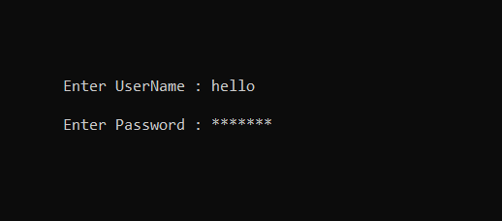

* ***Main Window:***
  + 1. Insert() : Used for inserting data into the file.
    2. Delete() : Used to delete a particular record from the file.
    3. Edit() : Used to edit the details stored in the file.
    4. List() : Used to display the records of the file.
    5. Search() : Used to search for a particular record in the file.
    6. DisplayPayslip() : Used to display the payslip of a employee.
    7. Holiday() : Used for managing the leave details.

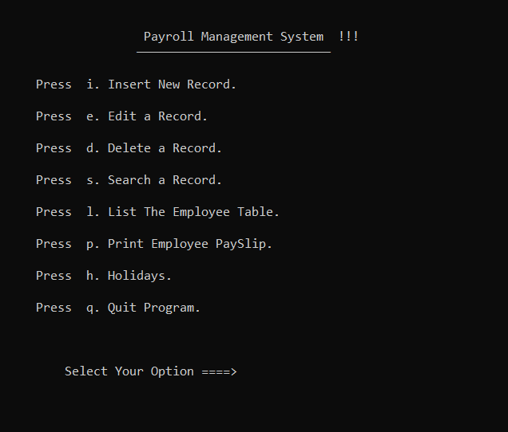

* ***Employees List:***

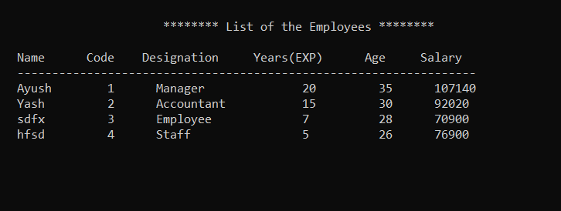

* ***Conclusion:***

This C++ project has helped me to understand more about object oriented programming.

The working of the project went quite well. I got to know the C++ library and file handling and understood how powerful the language is. I also got to know various platforms where I can learn about these libraries.

On browsing through the net I found various things that I should do in my project to make it better. Overall, it was a great experience for me as I got knowledge about various interesting topic.